Accreditation Report

##### Bethany Christian School

A Ministry of

Plano Bethany Bible Church

3300 W. Parker Road

Plano, TX 75075

972-596-5811

972-596-5814 fax

[Bethany.Christian@verizon.net](mailto:Bethany.Christian@verizon.net)

[www.bethanybible.com](http://www.bethanybible.com)

Accreditation Team

Team Chair: Ike Stokes

Member: Martha Stokes

Association of Christian Teachers and Schools (ACTS)

Jay Nelson, Ph.D., Executive Director

Steve Lindquist, M.A.T, M.ED., Director of Accreditation & Membership Services

911 S. Parsons Ave., Suite G

Brandon, FL 33511

Phone (813) 684-2024

Fax (813) 684-2026

Dr. Marvin J. Effa, Principal (Contact for self-study)

972-985-8827 (home); 214-527-7075 (cell)

Self-Study team: Marvin Effa, D. Min., Principal

Alan Winchester, M.A. Education, Assistant Principal

Sara Effa, B.S. Education, Registrar

Michael Fincannon, **M.S., LPC, LMFT,** Chairman of the Board

Steve Hendrix, Deacon and Safety Officer

April 10-12, 2017

Purpose: Bethany Bible Church, as the sole owners and operators of Bethany Christian School, requests re-accreditation from ACTS for our school program of K3 through 12th Grades, beginning September 1, 2017 through August 31, 2023.

Contents

History of the School 4

Standard 1, Philosophy 5

1. Evidence 1.1 Statement of Faith 5
2. Evidence 1.3a Board Approvals for Accreditation. 6
3. Evidence 1.3b Philosophy of Christian Education. 7

Standard 2, Governance 9

1. Evidence 2.1 Bylaws of Bethany Bible Church, Elders, page 10. 10
2. Evidence 2.2 Bylaws of Bethany Bible Church, Purpose. 10
3. Evidence 2.3 Picture of Corporation Documents. 10
4. Evidence 2.4 Bylaws, Article IV-The Church Board, Section 3-General Powers, page 9. 11
5. Evidence 2.4 Bylaws, Article X-Organization, Section 5-Christian School Ministry, page 13. 11
6. Evidence 2.5 Contractual Benefits. 11
7. Evidence 2.6 Six-Year School Improvement Plan. 12
8. Evidence 2.7 Incorporation and DBA. 13
9. Evidence 2.8 Additional Insured. 13
10. Evidence 2.9 Selection and Evaluation of Administrator, Church Bylaws, Article VIII, page 11. 14

Standard 3, Curriculum and Instruction 15

1. Evidence 3.9 Elementary and Secondary Report Cards. 17
2. Evidence 3.11 School Calendar 17
3. Evidence 3.13 Graduation Requirements for Secondary School. 18

Standard 4, School Staff 19

Standard 5, School Finances 22

1. Evidence 5.1a and Evidence 5.1b Texas Tax Exempt Ruling and IRS Tax Exempt Ruling. 23
2. Evidence 5.1c Audit Report. 23
3. Evidence 5.4 Schedule of Fees and Refund Policy. 23

Standard 6, School Facilities 24

1. Evidence 6.1 Specific Use Permit. 24
2. Evidence 6.2 Building Permits and Fire Inspection. 25
3. Evidence 6.3 Food Inspection Report. 25

Standard 7, Admission Procedures and Policies 26

1. Evidence 7.1 Admission Procedures and Policies. 26
2. Evidence 7.2 Governing Body Approval of Enrollment Process. 28
3. Evidence 7.4 Non-Discrimination Policy and IRS Form 5578. 28
4. Evidence 7.4 Non-Discrimination Statements on Webpages. 29

Standard 8, Records 30

1. Evidence 8.1 Student Records. 31
2. Evidence 8.4 Immunization Audit. 31
3. Evidence 8.5 Records and School Closure. 31
4. Evidence 8.6a FERPA Policy. 32
5. Evidence 8.6b Transfer of Records Policy. 32
6. Evidence 8.7a Personnel File Index and 8.7b Personnel Records Policy. 32

Standard 9, Student Activities 33

Standard 10, Publications 34

Standard 11, Student Data Analysis 35

Standard 12, Health, Safety, and Security 36

1. Evidence 12.2 Criminal Background Check Policy. 38
2. Evidence 12.4a Fire/Tornado Log. 38
3. Evidence 12.4b Fire Tag Inspections. 39
4. Evidence 12.6a Insurance Card for Bus. 39
5. Evidence 12.6b Hired Non-owned Coverage. 39

APPENDIX 1 ACTS Statement of Faith 40

# History of the School

Bethany Christian School began in 1979 as a pre-school. At that time, the church Board desired to assist mothers with the care of their children. As the ministry grew, the Board increased the grade levels. In 1982 the Board hired a new pastor who also supported their desire to develop a Christian school ministry. In the mid-1990s, the school recognized its first graduates from twelfth grade. Its graduates have done well on the standardized college entrance tests and almost all have gone on to college. Our graduates serve a variety of companies; several have attended Christian colleges while others have served the Lord on the foreign mission field.

In the early 1980s, the church began a theological shift toward conservative biblical thinking. By the mid-1980s, this theological shift began to impact the school. Teachers were required to be believers and the Board began to bring all programs associated with the church in line with our purpose statement. We believed that all aspects of the ministry should bring honor and glory to the Lord Jesus Christ. It took several years to develop a staff that was committed to discipleship; it took even longer to gather school families who shared that commitment. As an institution changes there is substantial developmental stress on the organization. Those who wanted a private school without an emphasis on discipleship increasingly found themselves at odds with the new direction set by the church Board. In the mid-1990s, the transition was completed and the school now seeks, whenever possible, to enroll Christian families whose children are reasonably self-motivated and self-disciplined. With those difficult transition years behind us, the school has continually been a blessing not only to the church, but also to many families within the larger Christian community of Collin County.

In 2010 the school applied for Federal recognition to provide education to nonimmigrant students through the Student Exchange Visitor Program (SEVP) and was approved on January 13, 2011. Since that time we have seen a steady increase in our foreign student population. Our graduates are now serving around the world and have been involved in formal Bible training through the ministry of the school. We often find ourselves working with students whose world view is cyclical and not linear. “When it rains, the dragon cries” is a typical worldview. We seek to inform them of the Creator and the creation as well as the coming conclusion to this current world. The Plano area where the school is located is increasingly Asian. Within walking distance are restaurants with no English, only Chinese, Vietnamese, and Korean.

The general population of the school consists of a wide range of ethnical backgrounds. Most of our students come from upper-middle class families who are able to pay for the full cost of the school year up front. In our area the public school does an excellent job with early-childhood education. The school offers discounts on tuition for these grades as well as a sibling discount to increase our attendance in K3-2nd grades. The SEVP tends to draw students who want a variety of educational experiences. It is not uncommon for students to qualify for college entrance and go directly to college without graduating from high school. Once they have a proficient level of English they will also transfer to larger schools.

The last several years all of our graduates have attended college. Last year University of Texas at Dallas, University of Iowa, University of California at Los Angeles, East Texas Baptist University, and Collin College all received our graduates and provided scholarships to many. In the last 10 years, we have had 2 graduates enter the military.

The Lord led us to ACTS for accreditation, and we were accredited on May 17, 2007, and reaccredited on May 15, 2012. We have filed our annual reports with ACTS for continued accreditation and have met all of the standards established for a school to maintain accreditation. We have found the last ten years a great blessing and we hope to continue our relationship with ACTS. ACTS fully understands the church/school model and is helping us reach our full potential.

# Standard 1, Philosophy

The school’s philosophy:

* 1. Shall be in agreement with an approved ACTS Statement of Faith.

The school’s statement of faith is in agreement with ACTS Statement of Faith as listed in the appendix found at the end of the accreditation standards. See Evidence 1.1 Statement of Faith.

* 1. Shall be sensitive to the needs of the pupils, both spiritually and academically.

Our teachers and administrators continually review the development of the students’ academic and spiritual progress. This is done through the classroom, staff meetings, and parent/teacher meetings. Whenever particularly difficult issues arise, we request additional meetings with the parents. The class day begins with prayer and devotions; during this time many students share personal needs and prayer requests. Chapel is a weekly occurrence for all students.

* 1. Shall be in written form and approved by the school’s governing body.

The Philosophy of Education is in written form and is found in the Student Handbook. The handbook was approved by the Board on June 19, 2013, and recorded in the minutes at the September 25, 2013, meeting. See Evidence 1.3a Board Approvals for Accreditation; Evidence 1.3b Philosophy of Education.

* 1. Shall be stated in school literature informing staff, parents, pupils, and prospective families of the school’s philosophy.

Our philosophy is not only listed on the first page of our handbook, it is also available on our web site; our office staff visits with each prospective family to ensure that we are what they are looking for.

* 1. Shall be used to guide the academic program and overall development of the school and shall be consistent with sound educational practices.

The three highlighted points of the philosophy define sound education: core biblical values, individual accountability, and a structured curriculum. The school uses this philosophy to both manage and make decisions pertaining to the development of student’s personal, emotional, academic, and spiritual components. The school uses Bob Jones University Press in all classes.

Commendations:

Recommendations:

### Evidence 1.1 Statement of Faith

Statement of Faith

We believe the Scriptures of the Old and New Testaments were verbally inspired and completely inerrant in the original writings. They are of supreme and final authority in faith and life.

We believe there is one God, eternally existing in three persons: Father, Son, and Holy Spirit.

We believe Jesus Christ was begotten of the Holy Spirit, and was born of the Virgin Mary. He is true God and true man.

We believe man was created in the image of God; he sinned and thereby incurred not only physical death, but also that spiritual death which is separation from God. All human beings are born with a sinful nature, and those who reach moral responsibility become sinners in thought, word, and deed.

We believe the Lord Jesus Christ died for our sins, according to the Scriptures, as a representative and substitutionary sacrifice. All who believe in Him are justified on the ground of His shed blood. Any person who, in simple faith, trusts in the risen Christ as his only hope of heaven, refusing to trust in anything else, receives the gift of eternal life which, once granted, can never be lost.

We believe the crucified Christ was bodily resurrected, ascended into Heaven, and lives today as our High Priest and Advocate.

We believe in "that blessed hope"--the personal, premillennial, and imminent return of our Lord and Savior, Jesus Christ.

We believe in the bodily resurrection of the just and of the unjust; the everlasting blessedness of the saved, and the everlasting punishment of the lost.

### Evidence 1.3a Board Approvals for Accreditation.

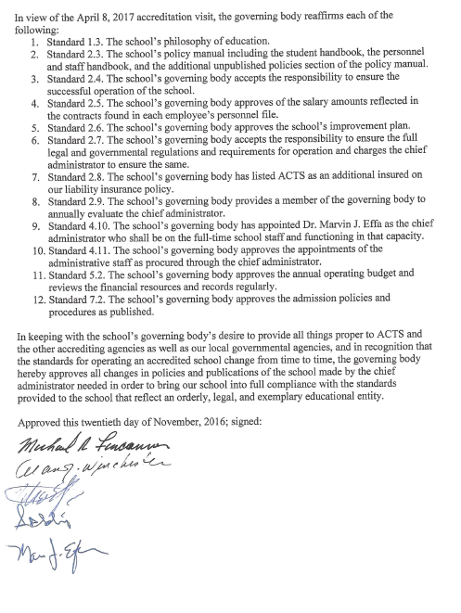

See #6 below, MSA, initial approval:

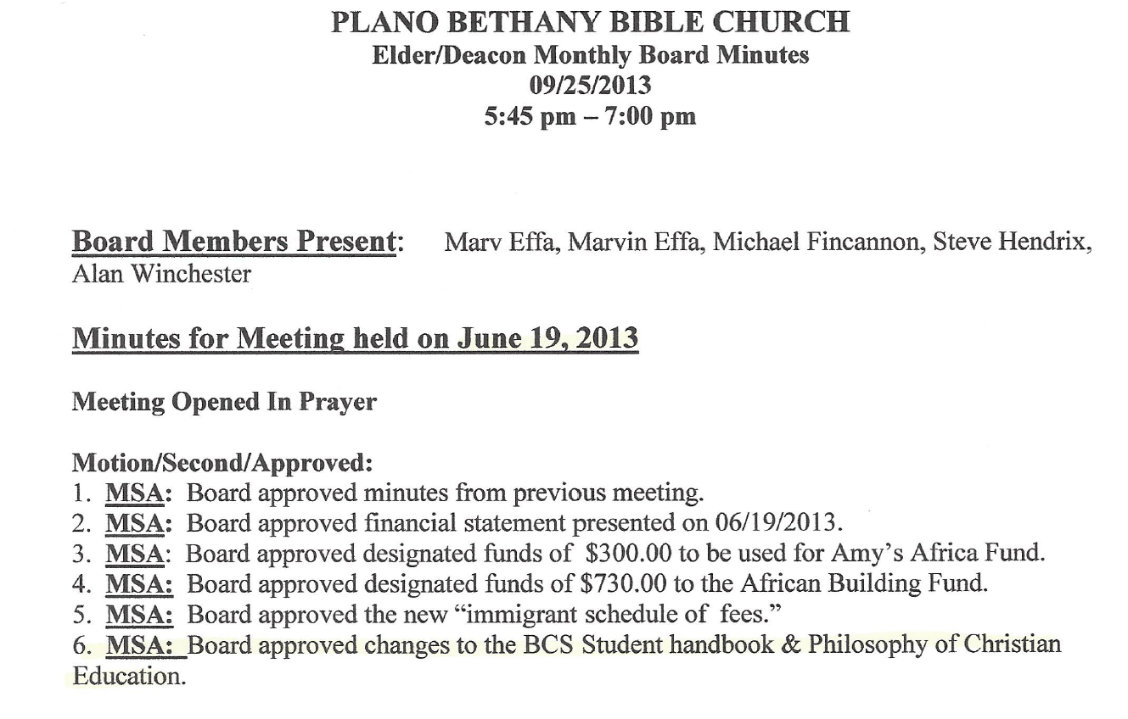

### Evidence 1.3b Philosophy of Christian Education.

We believe that the grace of God is foundational for a Christian school. Titus 2:11-15 is an excellent passage for declaring and demonstrating the amazing benefits of understanding and implementing God’s grace. No one deserves God’s love and grace; yet He loves us unreservedly and unendingly. God’s love for His alienated creatures causes Him to reach out in love and provision. We believe that this spirit of grace should permeate the educational environment. Our teachers strive to welcome each student in the same way God welcomes us.

Once grace is understood and integrated into our lives, it immediately begins to instruct us. It teaches us to make a break with ungodliness and worldly lusts. It teaches us to live lives that are self-controlled, consistent with God’s righteousness, and reflective of godliness; simply put, the grace of God teaches us to be godly. It also teaches us that there is a time yet coming when we will see our Savior face to face. His coming is the ultimate solution to the world’s problems, but until He comes, our task is to be zealously working what the Bible calls “good works.” We want our students to do well in all respects, but we want them to do well because they love our great God and Savior Jesus Christ.

As our excellent Christian teachers work together with our families to prepare students for life, we have found it helpful to call attention to several key educational issues:

1. **Core biblical values**. Properly understood, grace teaches us to respect God, teachers, classmates, and property. There is a way of life that honors the Lord and brings everlasting rewards. We reward good behavior and discipline bad behavior. The prevailing winds of our culture reward tolerance—the most enlightened is the one without rights and wrongs. We believe the Bible provides the instructions for us to live consistently with the grace of God.
2. **Individual accountability**. In an age of prevailing educational socialism, we believe each person is accountable and responsible to work up to potential. In some schools, groups earn a grade, but we believe that this is unproductive. Typically, one person takes the leadership and, eventually, everyone does less work. Individual accountability results in increased productivity. God’s grace does not exclude individual accountability but enhances it.
3. **Structured curriculum**. We have selected difficult curricula that advance students from one year to the next. This process begins in K3 where our students learn a phonetic approach to English and continues through grade twelve. We expect our graduates to be well read, well written, and well spoken. Some educational theorists advocate that teachers passively negotiate with the students and only take the learning opportunities when the students are ready to learn. We believe that the teacher should direct the learning process based on the curriculum required for that grade. Some students may require tutoring and/or summer school to learn the material, but most students who apply themselves are able to learn the curriculum through classroom instruction and homework.

We live in a society where schools differ greatly in their philosophy of education. Public schools typically endorse some form of secular humanism; some charter schools teach with an Islamic (Turkish) philosophy; some schools with Christian in their name embrace everything from ecology (going green) to extreme self-worth (no one fails).

The need for an academically solid school founded on the grace of God has never been greater. We actively seek families who agree with our statement of faith and our philosophy of Christian education. Should we enroll a student who has yet to believe, we will actively seek to bring each person to a saving knowledge of the Lord Jesus Christ and instruct the student in the grace of God.

# Standard 2, Governance

The governing body:

* 1. Shall be spiritual leaders.

The school’s governing body is identical with the church’s governing body. The church’s bylaws require males to meet the prerequisites listed in Scripture before serving in the office of elder. Deacons do not have polity-making authority. See Evidence 2.1

* 1. Shall govern the school in accordance with the stated philosophy.

The school, as a ministry of the church, follows biblical lines of authority and responsibility. The Board seeks to bring all aspects of the school’s functioning--whether staff issues, student academics, student life, or parent interaction--into submission to the Word of God. See Evidence 2.2 Bylaws of Bethany Bible Church, Purpose.

* 1. Shall be responsible for the formulation of policy and the maintenance of a school policy manual which must include nondiscriminatory policy and practices in admissions, employment and all other aspects of school operation. A complete and current record of all governing body minutes must be maintained.

The governing body maintains a policy manual that includes a nondiscriminatory policy for admissions, employment, and all other aspects of school operation. The policy manual may be found in the school office, and an electronic copy is included on the website prepared for the accreditation visit. A complete and current record of all governing body minutes are kept in the principal’s office. See Evidence 2.3.

* 1. Shall be responsible for the successful operation of the school.

The articles of incorporation, as well as the bylaws for the corporation, place the responsibilities for all aspects of the ministry, including the school, upon the Board. See Evidences 2.4 Bylaws, Article IV-The Church Board, Section 3-General Powers and 2.4 Bylaws, Article X-Organization, Section 5-Christian School Ministry.

* 1. Shall provide adequate salary and benefits for the staff and faculty.

The governing body provides adequate salary and benefits for the staff and faculty. Starting salary is $19,100 for the 2016-2017 school year. Bonuses, additional work such as assisting in administration or staffing additional programs are added to this amount. Contracts are available for review under Standard 4 and total numbers for the year are available under Standard 5. Benefits for non-ordained employees are provided below; see Evidence 2.5.

* 1. Shall develop and document a School-Wide Improvement Plan containing goals, measurable objectives, a timeline for completion and stakeholders involved. The Plan must address the areas of: Curriculum & Instruction, School Staff, Facilities, Student Activities, Student Data Analysis, Recommendations from the previous Accreditation Report, and Self-identified areas of needed improvement. (Minimum six-year plan)

The school has a six-year, school-wide improvement plan that contains the requirements of the standard. See Evidence 2.6.

* 1. Shall ensure all required governmental regulations are met (Incorporation, Fire, Health, Food Service, etc.).

The church was incorporated on December 8, 1975. Bethany Christian School functions through a DBA filed by the church. All inspections and permits are located outside the school office and in the kitchen. Specific inspections and permits are provided under Standard 12.1. See Evidence 2.7 Incorporation and DBA.

* 1. Shall list ACTS as an “Additional Insured” on preschool’s liability insurance policy.

ACTS is listed as an Additional Insured on our liability insurance. A full policy is available for review. See Evidence 2.8.

* 1. Shall be responsible for the selection and evaluation of the school administration.

The Board, an elder, or a Board member appointed by the Board evaluates the administrator on an annual basis. Evaluations are available in the administrator’s personnel file. See Evidence, 2.9, Selection and Evaluation of Administrator, Church Bylaws, Article VIII, page 11.

Commendations:

Recommendations:

### Evidence 2.1 Bylaws of Bethany Bible Church, Elders, page 10.

Article VI-Elders

Section 1-Qualifications and Responsibility

The men serving as Elders shall be members of this church, of high Christian character and shall maintain an exemplary reputation in all aspects of their lives, both in the church and in the world. They shall be both spiritual and temporal leaders of the church, and shall meet the qualifications and fulfill the responsibilities as set forth in Titus 1:5-9, 1 Timothy 3:1-7 and 1 Peter 5:1-3. They shall be responsible for overseeing the spiritual well-being and discipline of the church, and shall meet with the Pastor to provide counsel and prayer support for his ministry. Each elder shall understand and fully support the church’s Bylaws and Doctrinal Statement.

### Evidence 2.2 Bylaws of Bethany Bible Church, Purpose.

Page 3, Bylaws of Bethany Bible Church

Article 2-Purpose

The purpose of this church shall be: to proclaim the Gospel of the Lord Jesus Christ as a means of reaching unbelievers (Mark 16:15); to worship and glorify God (John 4:23-24); to edify believers in Christian living (Ephesians 4:12); to encourage and promote fellowship of the saints (1 John 1:3, 7); and to equip others for vocational Christian service (2 Timothy 2:2) as taught in Scripture.

### Evidence 2.3 Picture of Corporation Documents.

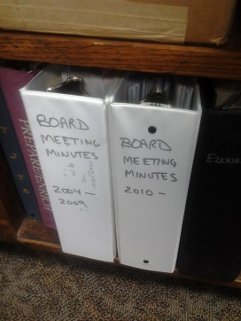

### 

### Evidence 2.4 Bylaws, Article IV-The Church Board, Section 3-General Powers, page 9.

All the corporate powers and the ownership of all property of this corporation shall be vested in the Board. The Board shall have power to appoint, compensate and discharge officers and employees of the corporation and all persons, councils and committees designed to carry out the work of the corporation. All officers, employees of the corporation shall have such powers as may be delegated to them by the Board. The Board shall have the power by and through its duly constituted officers to acquire, hold, use and dispose of property of the corporation.

### Evidence 2.4 Bylaws, Article X-Organization, Section 5-Christian School Ministry, page 13.

In keeping with our commitment to disciple and educate children and young people, we commit ourselves as a corporation to the ministry of Christian education. The Board shall establish and oversee a Christian school ministry that is in keeping with the purposes, philosophy, and operational concepts as spelled out in the Bylaws and Doctrinal Statement. The Board shall approve the philosophy of ministry, operational handbooks, schedule of fees, and the enrollment process of the school.

### Evidence 2.5 Contractual Benefits.

**Non-cash Benefits for Non-ordained Employees**

The following non-cash benefits are subject to the laws of the State of Texas and the Internal Revenue Code. An employee is eligible for the following benefits when he/she is employed more than 25 hours per week and is at least 18 years of age.

1. Eligible employees receive Personal Time Off to be used however the employee wishes. Personal Time Off is accrued by pay period and may be cashed in at a reduced rate only at the last paycheck of May. Personal Time Off may not be cashed in if either party terminates the contract. The employee will be charged for Personal Time Off beyond the accrued amount.
2. The ministry matches Social Security and Medicare deductions from each staff member’s paycheck.
3. Eligible employees may participate in a 403(b) Tax Sheltered Annuity. Please refer to Bethany Bible Church’s Tax Sheltered Annuity Agreement form for details.
4. Bethany Bible Church shall provide all employees with Workers’ Compensation.
5. Bethany Bible Church will provide eligible employees with a 50% discount on tuition, registration fees, educational fees, summer programs, before school care and after school care. Student trips, activities, meals and incidental expenses will not be discounted. Students must meet the entrance requirements of the school and are subject to the rules of the Schedule of Fees as posted in the office.
6. Bethany Bible Church shall provide educators’ liability insurance in the minimum amount of $100,000 with a $1,000 Retention Clause. This benefit is available through our insurance company.
7. It is the desire of Bethany Bible Church that all employees comply with the laws regarding health insurance. When possible the corporation will assist employees in complying with the law. Please set up a time to discuss your particular needs with the principal.
8. Bethany Bible Church will pay for eligible employees to have up to six sessions per school year with Michael Fincannon, MS, L.P.C., L.M.F.T. The principal must approve this benefit and you must provide him with the dates and times of your kept appointments. Since there can be no exchange of information between the school and/or the principal and Mr. Fincannon, you must inform the principal so that proper payment to Mr. Fincannon can be made.

### Evidence 2.6 Six-Year School Improvement Plan.

Six-Year Plan for Bethany Christian School 2017-2023

It is our desire, by God’s help, to implement the following improvements to our ministry:

|  |  |  |  |
| --- | --- | --- | --- |
| Goal | Measurement | Timeline | Stakeholders |
| Curriculum and Instruction: Draw attention to the centrality of curriculum instruction by the staff. | Terra Nova testing provides a measurement for student comprehension. | Annually at graduation provide a cash bonus and certificate to the teachers who demonstrate skillful curriculum instruction. | All staff, parents, and students at graduation will recognize the emphasis on curriculum usage and instruction. |
| School Staff: All staff will be paid to attend the ACTS conference for training and development. | Attendance sheets are required for each staff member and are incorporated into personnel folders. | Annually in November. | All teaching and non-teaching personnel. |
| Facilities:   1. Repaint the outside of the building 2. Replace bathroom partitions 3. Replace the carpet in the main building 4. New roof on back of building. 5. Replace the storage building 6. Replace the windows in the annex and appliance room 7. Add a 400-square-foot temporary building with a bathroom. | Work is completed. | By the end of August 31,   1. 2017 2. 2018 3. 2020 4. 2022 5. 2020 6. 2017 7. 2023 | School and church families via letters and presence in the facility. |
| Student Activities:  Have at least one all-school assembly each year with special events. | Inclusion of events in the yearbook. | Annually | Parents are invited to join students at the special assembly. |
| Student Data Analysis: Review the academic progress through standardized tests and evaluate effectiveness of curriculum. | The scores will be charted by class and recorded for year-to-year comparison. | Annually in June after scores have been received. | Results will be communicated to teachers during in-service and with the parents in the first letter of the school year. |
| Recommendations from Previous Accreditation: The school had no recommendations at the last accreditation visit in 2012. |  |  |  |
| Self-identified Areas of Needed Improvement: The church needs to increase its size and ministry to school families if the school is to continue to thrive. | Count the number of school families that join the church | Annually in November. | Current church families are notified via public recognition of new school families. |

### Evidence 2.7 Incorporation and DBA.

|  |  |
| --- | --- |
|  |  |

### Evidence 2.8 Additional Insured.

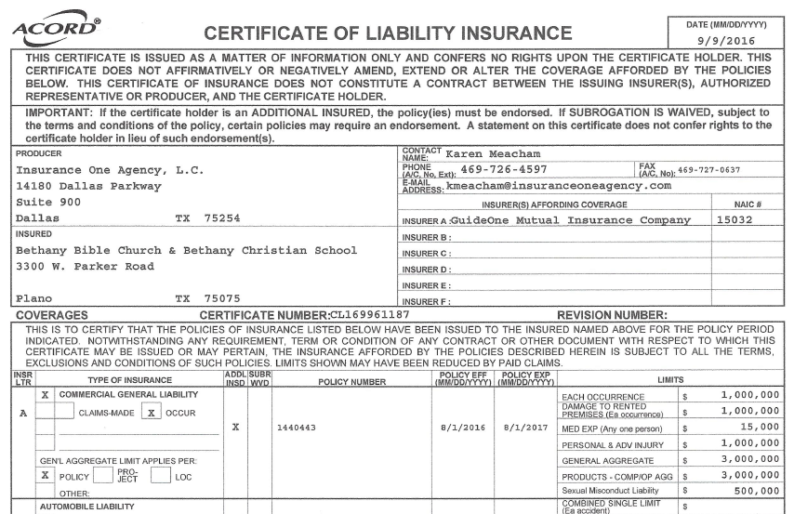

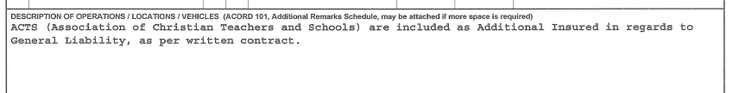

### **Evidence 2.9 Selection and Evaluation of Administrator, Church Bylaws, Article VIII, page 11.**

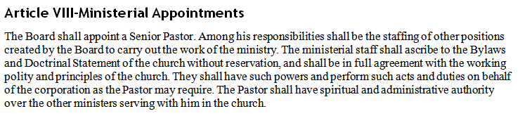

Standard 3, Curriculum and Instruction

The curricular and instructional program of the school:

* 1. Shall be consistent with the school’s philosophy.

Bethany Christian School utilizes the BJU Press curricula in K3 through 12th grade. This curriculum is endorsed by ACTS and is superior in producing critical-thinking disciples. A unified, single curriculum assures consistency in scope and sequence. Although expensive, BJU Press is superior to the other Christian and secular options. Not all subjects are available through BJU Press. We supplement the curriculum with Cambridge Latin, and Dave Ramsey’s curriculum for Consumer Math.

* 1. Shall incorporate a biblical world view into each subject area.

The staff uses the BJU curriculum that has built into each subject a Creation, Fall, Redemption format. Believers are to excel because God has charged them to exercise dominion. These themes are consistently found throughout every grade level.

* 1. Shall provide appropriate learning experiences that address student needs as determined by a formal assessment program that includes but is not limited to normed standardized testing.

Regular, formal assessments are built into the BJU Press curriculum. The secondary school has final exams the last week of each semester. Terra Nova standardized tests are administered to the K through 12th grades during the first week in April. Results from the standardized tests and the curriculum exams are used to modify classroom instruction. See Standard 11 for additional information. Results of Terra Nova testing are submitted with each CAR. See Evidence PSAT/NMSQT Report provided on the website developed for the accreditation visit.

* 1. Shall engage students in their learning through instructional strategies that ensure achievement of learning expectations.

A variety of learning strategies are utilized. Lectures, field trips, a week-long Spiritual emphasis trip, homework, roleplaying, manipulatives, competitions, videos, et cetera, are utilized. Students are also encouraged to participate in afterschool clubs, such as Yearbook Club, computers, and Robotics Club.

* 1. Shall provide and coordinate learning support services to meet the unique learning needs of students.

Tutoring is available at no charge before and after school. If a student needs more than this, tutoring by a teacher is available on a sliding scale range.

* 1. Shall provide curriculum guides detailing scope and sequence for the instructional program at each grade level.

The school follows the standardized scope and sequence provided by BJU Press. This is available online and a printed copy is available in the school office. Each of the teacher’s editions assists the teachers in understanding the larger, instructional picture.

* 1. Shall provide appropriate curriculum materials for the student population.

Curriculum has been purchased for each student; additional educational materials have been purchased and are kept on hand for any student arriving after the school year begins. Educational materials are a major expense for the school, as evidenced by Standard 5.

* 1. Shall be formally and systematically evaluated by the school and revised as needed.

We rely on the Bob Jones University Press to update and revise the standard curriculum materials. Whenever new editions come out, we replace the older editions with the new. The administrators also meet during the summer and review the academic progress of the students. At that time they evaluate the Terra Nova test scores and prepare for in-service with the teachers. Directions are provided to the teachers during in-service regarding emphases and adjustments from the administrators’ evaluation.

* 1. Shall develop and maintain a systematic process for reporting student achievement.

Report cards are issued every nine weeks, and progress reports are issued at the end of the fifth week of each quarter to students with 75 or below, or to students with unacceptable behaviors. Upper School (7-12) report cards are generated through the school office and are professionally printed. Teachers submit the grades to the office. See Evidence 3.9 Elementary and Secondary Report Cards.

* 1. Shall provide adequate information to students and parents about the grading and assessment policies of the school.

All of the grading policies are listed in the Student Handbook. Each parent or guardian must sign progress reports. Time for Parent-Teacher conferences is provided at the end of the first quarter and our teachers are available for before-and-after school conferences. The office delivers other notifications such as a notice of an academic deficiency directly to the parent at carpool.

* 1. Shall be designed in the best interests of the students and shall have a minimum of 180 actual school days or a minimum of 170 actual school days and the hourly equivalent of 180 actual school days determined as described below. (If the state requires an actual number of attendance days, the school must meet state/government requirements.)

A. Kindergarten: 540 net instructional hours

B. Grades 1-3: 720 net instructional hours

C. Grades 4-12: 900 net instructional hours

The school has 170 days for K3-12th grades; each school day is 8:30-3:30, Monday – Friday and is published in the school calendar. We also have an additional 7 days of in-service for our staff. The net instructional hours are 1190 per year. This allows us to have the odd bad-weather day without making up the day. See Evidence 3.11. The State of Texas exempts private schools from attendance requirements provided the school teaches students to be good citizens. (Tex. Education Code Ann. § 25.086 (a) (1))

* 1. Shall provide for appropriate teacher planning and preparation time.

Each teacher has one free period per day for planning and preparation. We have instructors for PE, music, and art. These instructors allow teachers appropriate time for planning and preparation.

* 1. Shall provide curriculum including subjects which constitute a well-balanced educational program and meet or exceed required government graduation requirements.

The school requires 28 credits for graduation. Comparing our requirements to the state’s, shows that we utilize an advanced curriculum. We do not offer AP classes because all of our BJU Press materials are already advanced compared to the public school standard classes. Students entering as “not-proficient, F-1 students” have their foreign language credits replaced by additional English credits. Once they become proficient, they are required to take a foreign language, typically French or Spanish. See Evidence 3:13 Graduation Requirements for Secondary School.

* 1. Shall teach Bible as an academic subject at every grade level with a minimum of three hours of instructional time per week.

Bible is an academic subject. Secondary school students must earn 4 credits of Bible; elementary students receive a grade in Bible and it is taught every day. The school also has weekly, age-appropriate chapels and each school day is begun with prayer and a devotional.

* 1. Shall provide a library/media and technology center with current, adequate reference, print, non-print materials, books, and technology for the needs of students.

Non-curriculum books are kept in the homeroom of each grade level with a minimum of 10 books per student; we provide teacher-monitored access to the internet and subscribe to Lynda.com, a $39 per month resource that provides a very large number of instructional materials to the students. The school has purchased laptops and software to allow each student access for research and study. We converted our former computer lab into an art room, because laptops do not require the setup and space that the old tower configurations required.

* 1. Shall properly catalogue all resources.

Books have been stamped and recorded in a catalogue.

* 1. Shall implement the school’s instructional process in support of student learning.

Long-term learning happens only when the student “owns” the learning process. Extra-curricular activities provide for a well-balanced and wide range of learning experiences. The school balances the academic disciplines with the enjoyment of life that only a Christian can know. This balance provides for a high level of student ownership of the academic process. We frequently have graduates return to the campus because the school has been their academic and spiritual home.

Commendations:

Recommendations:

### Evidence 3.9 Elementary and Secondary Report Cards.

|  |  |  |
| --- | --- | --- |
|  |  |  |

### Evidence 3.11 School Calendar

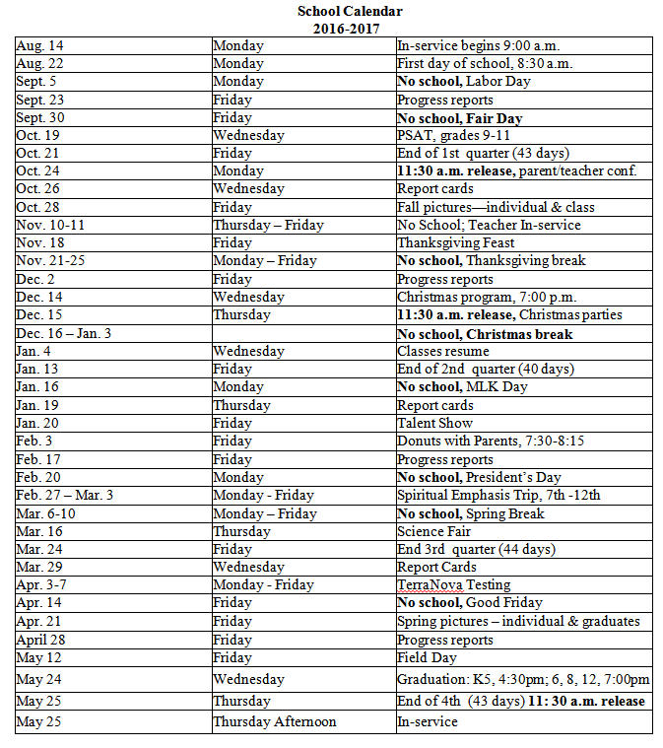

### Evidence 3.13 Graduation Requirements for Secondary School.

From our transcripts:

|  |  |  |  |  |
| --- | --- | --- | --- | --- |
|  |  |  |  |  |
|  |  |  |  |  |



# Standard 4, School Staff

* 1. All members of the school staff shall be Christian and shall exhibit Christian character in all areas of life.

A Spiritual Life portfolio is included in each employee’s personnel file. The portfolio allows each member to express in his/her own words their personal relationship with Christ. It is our endeavor to adorn the gospel of grace with Christian character. When necessary, appropriate interaction is provided to encourage adherence to the high standard of Christ’s calling.

* 1. All school personnel (full/part time staff or any volunteers) are required to undergo a background check prior to their employment or being given access to students.

All school personnel have undergone background checks; evidence of the checks is found in the personnel files. Volunteers receive background checks before gaining access to the students. Please see standard 12.2 for policies pertaining to volunteers and background checks.

* 1. Hold a bachelor's degree and an ACTS teaching certificate (core instructors). Additionally, all staff shall be qualified for whatever assignment given by the governing Board.

All of the school’s teachers are qualified to perform their assignments. All teachers have applied or have received ACTS teaching certificates. Two staff members do not have bachelor’s degrees. Ora Lockheart teaches our 3-4 year olds and has many years’ experience and specialized training for this age group. Texas does not require a bachelor’s degree to hold this non-academic class. She is amply qualified for the position she holds. John Huckle is our Athletic Director. He has an A.A., a wealth of experience in athletics and is a professional soccer coach of an at-risk girls’ soccer club. He has an academic plan in place and is working toward the 25 hours needed for his bachelor’s degree in an educational track at Dallas Christian College. He is amply qualified for the position he holds. Our school aides, the Directory of Hospitality, substitute teachers, and non-core, part-time, adjunct instructors (i.e. art, music, bee keeping, and creative writing) are not required to hold bachelor’s degrees nor be licensed by ACTS.

* 1. Show evidence of continued professional growth as evidenced by documented participation in the school’s professional development and/or college or continuing education credit.

Continuing education endeavors are documented and kept in each employee’s personnel file. This year we will provide 7 days of in-service training. All teachers and staff attend the annual ACTS conference.

* 1. Deal professionally with students, parents, staff, and administration.

The community to which we minister consists primarily of professional individuals who expect our staff to act in a professional manner. On a personal level, our staff is expected to deal with all other human beings with love and therefore patience, kindness, goodness, and gentleness.

* 1. Be sufficient in number to assure a faculty-pupil ratio that is appropriate to the type of curriculum used.

At the time of writing, we have 111 students and 10 full-time teachers, 4 part-time teachers, and 1 adjunct instructor.

* 1. The support staff shall be sufficient in number as to provide adequate clerical assistance to the school.

The school has adequate support staff with 2 full-time and 2 part-time staff members providing clerical assistance.

* 1. The school shall provide a custodial staff sufficient to maintain a clean and safe environment.

The school has utilized students who want to work after school to clean the school. One of these students with management skills is appointed to oversee the work. The students are paid more than they could earn at local businesses. We currently have about 10 students who work in this capacity. Students are eligible to work once they are in seventh grade.

* 1. The school shall provide in any other service areas (i.e. student health services, guidance services, food services, transportation services, etc.) adequate and competent staffing or an auxiliary plan or system that meets state and local regulatory requirements.

Our Registrar is licensed by the State to provide hearing, vision, and scoliosis screening. We have a lunch lady who is a certified food handler and three, on-site employees who are certified food managers (the highest licensing provided by the State of Texas and adequate for restaurant management). We have an 80-passenger bus and two drivers with CDL Class B School Bus licenses. Guidance services are provided by our homeroom teachers, the Assistant Principal, and the Principal.

* 1. The school’s governing body shall appoint a full-time person as the chief administrator and who shall be on the full-time school staff and functioning in that capacity.

The school has a full-time administrator who has life-time credentialing from ACTS. An assistant administrator is available to assist in administrative duties.

* 1. All administrative staff shall hold a bachelor’s degree, an ACTS Administrator certificate, and be qualified for assignments given by the governing body.

The Registrar has a bachelor’s degree in education, the Assistant Principal has an ME, and the Principal has a doctorate.

* 1. All administrative staff shall show evidence of continued professional growth as evidenced by documented participation in the school’s professional development and/or college or continuing education credit.

All teachers and most of the staff attend the ACTS conference and in-service training provided by the school.

* 1. All administrative staff shall deal professionally with students, parents, staff, and administration.

The community to which we minister consists primarily of professional individuals who expect our administrators to act in a professional manner. Our commitment to Christ requires respect of others.

* 1. The chief administrator and principal of each school shall attend an ACTS approved conference on an annual basis.

All of our teachers and most of our employees attend the ACTS conference each year; a number of our personnel assist in teaching at the conference and in the administration of the event.

* 1. The school shall establish a formal and systematic process of faculty/staff evaluation which shall be conducted on a periodic basis.

All employees have a minimum of an annual evaluation in their personnel file. A special, non-teaching evaluation form is used for non-teaching employees.

* 1. The school shall provide for a formal systematic process of annual staff development.

All employees are paid to attend in-service and ACTS conferences.

* 1. Mentoring, coaching, and induction programs support instructional improvement consistent with the school’s values and beliefs about teaching and learning

The school offers a variety of after school sports and clubs, including some that function during school. Yearbook Club is combined with a computer elective that provides a hands-on learning experience of producing something beneficial for the whole school. Students also produce their own video recordings for use in chapel. Samples of the students’ work are available for viewing on YouTube and the website built for this accreditation visit.

* 1. The school engages families in meaningful ways in their children’s education and keeps them informed of their children’s learning progress.

Parent volunteers are used in a variety of ways in different classrooms, according to the teachers’ needs. In addition to the normal report card and parent-teacher meetings, the school comes together for a whole-school Thanksgiving dinner with the food provided by the school, a Christmas program, Donuts with a Parent Day, and a graduation ceremony. This allows stakeholders multiple opportunities to enjoy and participate in the student’s learning process.

* 1. The school provides services that support the counseling, assessment, referral, educational, and career planning needs of all students.

The school participates in outside resources for college and career planning. Our homeroom teachers in the secondary school provide assistance to the students in planning for the future. We have five, full-time teachers working in the secondary school. This is adequate to provide opportunities for one-on-one care.

Commendations:

Recommendations:

# Standard 5, School Finances

The school:

* 1. Shall provide evidence of an annual external audit or review, sound, professional, ethical, and legal practices in all financial operations.

All fiduciary trust matters are noted and maintained. We use a cash system of accounting and the Board has avoided borrowing money. Tuition is collected and records of such are maintained through the school office. The principal is responsible for the payment of bills and payroll. Receipts and expenditures are never handled by the same person. Monthly statements are provided to the governing Board. In the past the Board treasurer audited the school books and recorded his findings in a letter submitted annually with the CAR. Due to a change in ACTS accreditation standards requiring an external audit, the school has retained the services of Paul Ko, P.C., CPA, 4317 Wonderland Dr., Plano, TX 75093, who is currently in possession of the books for 2015 and has a current copy of our Quick Books ledgers. His findings will be available for the CAR report filed in August of 2017 and will provide a review of both 2015 and 2016. Yearly presentations are made to the congregation in February. Annual profit/ loss statements and balance sheet statements are available for public view in the foyer. Filings required by the Federal government (941, W-2, W-3, I-20) are all located in the pastor’s office and available for review, but are not included in this document due to the sensitive nature of the material. See Evidence 5.1a Texas Tax Exempt Ruling, Evidence 5.1b IRS Tax Exempt Ruling, and Evidence 5.1c Audit Report.

* 1. Shall present evidence of adequate and identifiable financial resources and records to operate the school’s program with a realistic annual operating budget approved by the governing body and reviewed regularly.

The Board reviews and approves the financial report at each meeting. The reports are entered chronologically into the corporation minutes and are available for examination. Provided for the self-study visit are 3 bank statements for Dec. 31, 2016 (the corporation only has 3 accounts at this time), a profit-and-loss statement by class (church and school) for 2016, and a balance sheet for Dec. 31, 2016. The bank statements provide proof that the balance sheet is fully funded. We do cash accounting only and not accrual accounting, so no documentation is provided for buildings and contents. Due to the complexity of the financial documentation, evidence is listed separately from this document and may be found as a separate file found on the website built for the accreditation visit. Please see Financial Documents .

* 1. Shall document all fundraising and resource development activities.

The school does not engage in fund raising. We do receive offerings, usually at Christmas; donors receive tax-deductible receipts for their contributions and no portion of the donation is for any products or services rendered.

* 1. Shall publish a tuition and fee schedule that includes a tuition refund policy.

The schedule of fees has a refund policy included. See Evidence 5.4

Commendations:

Recommendations:

### Evidence 5.1a and Evidence 5.1b Texas Tax-Exempt Ruling and IRS Tax-Exempt Ruling.

|  |  |
| --- | --- |
|  |  |

### Evidence 5.1c Audit Report.

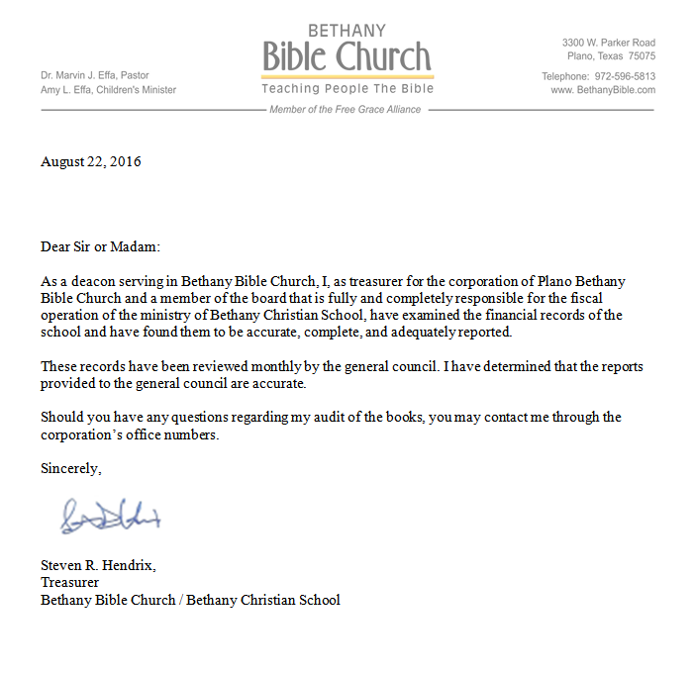

### Evidence 5.4 Schedule of Fees and Refund Policy.

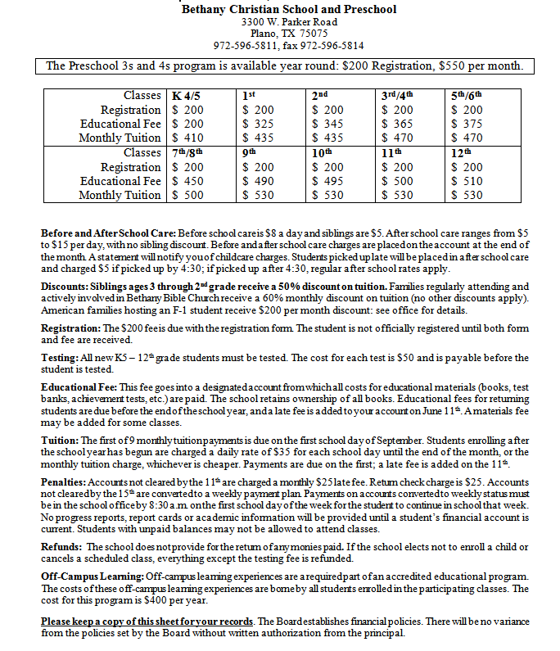

# Standard 6, School Facilities

*All school facilities*:

* 1. Shall be adequate in size, furniture, and equipment for the type of school program offered and for the size of the enrollment.

The school building is approximately 14,000 square feet and is adequate for the K3-12th grade program we run. Our current specific use permit allows up to 150 students. The furniture and equipment are adequate to care for the needs of the students and staff. See Evidence 6.1 Specific Use Permit.

* 1. Shall be safe, clean, attractive, and meet all pertinent building, equipment, health and other legal requirements.

The building is safe, clean, and attractive. All building, equipment, health and other legal requirements are met. See Evidence 6. 2 Building Permits and Fire Inspection.

* 1. Shall have clean, sanitary and regularly inspected kitchen and dining areas and comply with all legal requirements, (if food service is offered).

The building is cleaned every day, Monday through Friday. We have a lunch lady who cleans the kitchen before and after food preparation. We offer a reheat operation only and do not do a full service food preparation. We have 3 current Certified Food Manager certificate holders and one Certified Food Handler. Certificates are on display in the kitchen. See Evidence 6.3 Food Inspection Report.

Commendations:

Recommendations:

### Evidence 6.1 Specific Use Permit.

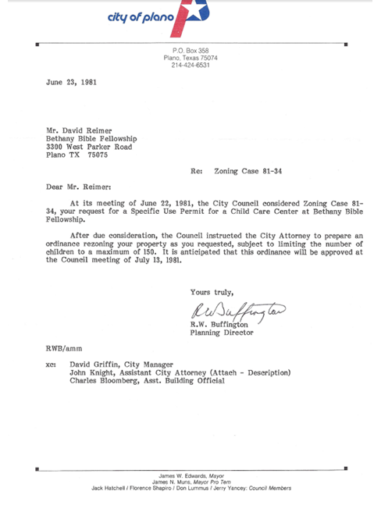

### Evidence 6.2 Building Permits and Fire Inspection.

|  |  |  |
| --- | --- | --- |
|  |  |  |

### Evidence 6.3 Food Inspection Report.

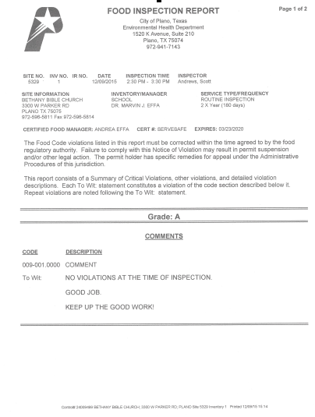

# Standard 7, Admission Procedures and Policies

*The school’s admission procedures and policies:*

* 1. Shall be clearly written in the student handbook.

The school’s admissions policies are clearly written in the student handbook and in the enrollment packet that is published on the website and handed to all prospective families. Application to the school begins by filling out a registration form and paying the registration fee. Admission Procedures and Policies are covered in Section 8 of the Student Handbook, page 12. See Evidence 7.1 Admission Procedures and Policies.

* 1. Shall be formulated by the governing body.

The governing body specifically approved the enrollment process in 2006 and reapproved the handbook in 2013. See Evidence 7.2 Approval of Enrollment Process.

* 1. Shall be written in such a manner as to admit only those for whom the program is designed.

The Philosophy of Education states: “We actively seek families who agree with our statement of faith and our philosophy of Christian education. Should we enroll a student who has yet to believe, we will actively seek to bring each person to a saving knowledge of the Lord Jesus Christ and instruct the student in the grace of God.”

* 1. Shall contain a published policy of non-discrimination and demonstrate consistent adherence.

The non-discrimination policy is published in all of the school’s publications and on the school’s website. The school has also received approval from the Federal government to enroll nonimmigrant students. This status requires proof that the school does not discriminate illegally. See Evidence 7.4, Non-Discrimination Policy and IRS Form 5578 and Non-Discrimination statements from the websites.

* 1. Shall address financial and other contractual arrangements between the school and parents/students.

By a signature on the registration form, all parents state their agreement with our schedule of fees. This original is kept in our records. The schedule of fees addresses all of the school/parent financial responsibilities, and clearly states the obligations of both school and the responsible party. See Evidence 5.4 Schedule of Fees listed under Standard 5, Finances.

Commendations:

Recommendations:

### Evidence 7.1 Admission Procedures and Policies.

8. Admissions

**Non-Discrimination Policy**

Bethany Christian School admits students of any race, color, national and ethnic origin with all rights, privileges, programs, and activities generally accorded to students of the school. It does not discriminate on the basis of race, color, national and ethnic origin in administration of its policies or programs.

**Admissions Policies and Procedures**

An enrollment package is available in the school office or online. Registration forms will not be processed without payment of the registration fee. The administration may waive certain forms for students transferring from like-minded Christian schools. SEVIS students who enroll using Bethany for the Form I-20 F1 visa shall follow the policies listed on the website for nonimmigrant students.

Private primary schools are required to request records when enrolling a child under 11 years of age to verify the child’s name, birth date, and previous school records. If documentation is not provided, the school shall notify the appropriate law enforcement agency to determine if the child has been reported missing. Law enforcement agencies shall immediately notify each school, including private primary schools, when a report of a missing child is received. (Tex. Code of Criminal Procedure Ann. Chapter 63.019)

Bethany Christian School’s biblical role is to work in conjunction with the family to mold students to be Christ like. On occasion, the atmosphere or conduct within a particular home may be counter, or in opposition, to the biblical lifestyle the school teaches.

As a private institution, Bethany Christian reserves the privilege of setting and maintaining its own standards for student conduct, dress, and scholarship. It is understood that to be a student at Bethany is a privilege and not a right. Any student who does not conform to the standards and regulations of the institution may forfeit this privilege. The school maintains the right to admit only those students who are in harmony with the standards of the school. The school may expel any student at any time, who, in the opinion of the school, does not share the spirit of the institution--regardless of whether or not the student conforms to the specific rules and regulations of the school.

**Homosexual/bisexual issues**

Bethany retains the right to refuse enrollment to or to expel any student who engages in sexual immorality, including any student who professes to be homosexual/bisexual or is a practicing homosexual/bisexual, as well as any student who condones, supports, or otherwise promotes such practices (Leviticus 20:13, Romans 1:27).

**Grade Placement**

The Academic Affairs Council shall determine the grade placement of students when placement is not obvious. New students must be tested by a nationally normed placement test. The cost of testing and the administration of the test are to be borne by the applicant.

While we realize that a particular student's academic readiness or ability is not always tied to age, we seek to establish classes where children of the same age are in the same class. If we allow a mature 4-year-old to enter kindergarten, the child must spend two years in Kindergarten. We have established policies that place students according to age and not ability only. If a student is too young, the Academic Affairs Council may grant enrollment to a student who is within 30 days of meeting the deadline (i.e. someone whose birthday is September 30 applying for first grade). If a student is too old, the school shall not enroll nor re-enroll any student who is two or more grade levels behind the grade that they should be. The following shall apply for determining appropriate age/grade status:

Five by September 1 go into kindergarten

Six by September 1 go into first grade

Seven by September 1 go into second grade

Eight by September 1 go into third grade

Nine by September 1 go into fourth grade

Ten by September 1 go into fifth grade

Eleven by September 1 go into sixth grade

Twelve by September 1 go into seventh grade

Thirteen by September 1 go into eighth grade

Fourteen by September 1 go into ninth grade

Fifteen by September 1 go into tenth grade

Sixteen by September 1 go into eleventh grade

Seventeen by September 1 go into twelfth grade

**Visa Issues**

Due to the complexities of visas provided by the Federal government, it is the responsibility of each student to maintain the requirements of his/her particular visa. Bethany Christian is authorized to issue the Initial I-20 form and enroll students under the F-1 nonimmigrant visa program. Students who are in the US under a Visitor’s Visa are generally allowed to engage in study that is merely avocational or recreational in nature. Academic records are kept only for F-1 visa students unless the school is notified in writing that a student is eligible to attend school on a visa other than the F-1 visa. Students in the US with a Visitor’s Visa are expected to maintain the highest level of excellent behavior; should a teacher determine that a student’s presence is detrimental to the classroom, the privilege of attending will be revoked.

### Evidence 7.2 Governing Body Approval of Enrollment Process.

|  |  |
| --- | --- |
|  |  |

### Evidence 7.4 Non-Discrimination Policy and IRS Form 5578.

|  |  |
| --- | --- |
| **Non-Discrimination Policy**  Bethany Christian School admits students of any race, color, national and ethnic origin with all rights, privileges, programs, and activities generally accorded to students of the school. It does not discriminate on the basis of race, color, national and ethnic origin in administration of its policies or programs. |  |

### Evidence 7.4 Non-Discrimination Statements on Webpages.

<http://www.prekcenterplano.com>

<http://www.planochristianschool.com>

For the church website: <http://www.bethanybible.com>

|  |  |
| --- | --- |
| Early Childhood Website | Christian School Website |

# Standard 8, Records

* 1. Records shall be kept in a safe, secure, and professional manner (fireproof or electronically current, retrievable dual backed format).

The school has employed a registrar whose first duty is to establish and maintain student records. Only the principal, registrar, and office personnel have keys to the student records. The records are maintained within the school office which has self-locking doors and restricted access. The fireproof file cabinets are also locking cabinets. See Evidence 8.1 Student Records.

* 1. Student records shall be kept on each student enrolled in the school.

Each student enrolled in the school has his/her own permanent academic file.

* 1. Student records shall be updated on a regular basis.

The records are updated on a regular basis and serve as the foundation for charting the students’ development while at the school.

* 1. Student records shall include academic, health, discipline and other pertinent information.

All academic notices are placed in the files. Each file has a section for immunization compliance and the school employs a retired nurse to make sure the immunization records are in compliance with State requirements. Discipline issues are placed in the student files, but are not carried forward from year to year; each student starts the new school year without infractions from the previous year. See Evidence 8.4 Immunization Audit.

* 1. The school shall make provision for the permanent maintenance of all student and faculty records, which includes a policy for the permanent retrieval and storage in the event of school closure. (Electronic copy of said plan must be submitted each year with annual report.)

Provision has been made with ITOP Christian Academy at 2010 E. Lancaster Ave in Fort Worth Texas 76103, 817-885-8875 to take the school’s records. See Evidence 8.5 Records and School Closure.

* 1. Access to student records shall follow the provisions of all local, state, and federal regulations relating to an individual’s right to privacy.

Records and transcripts may not be released to a parent or guardian without the permission of the principal. Certified copies are not available to parents or guardians, and are only mailed directly to an educational institution upon our receipt of that institution’s request. Records of a student enrolled under the F-1 program who illegally transfers to a school not authorized to enroll nonimmigrant students are not transferred. See Evidence 8.6a FERPA Policy and Evidence 8.6b Transfer of Records Policy.

* 1. Personnel records for faculty and administration shall include transcripts, contracts, tax records, form I-9, evaluations and professional licensure (ACTS certification).

The transcripts, contracts, I-9s and W-4s, and professional credentialing are included in the personnel file. Annual tax records are kept with the corporate documentation and not in the personnel file. The personnel files are arranged alphabetically so that each of the required items is found rapidly. See Evidence 8.7a Personnel File Index and Evidence 8.7b Personnel Records Policy.

Commendations:

Recommendations:

### Evidence 8.1 Student Records.

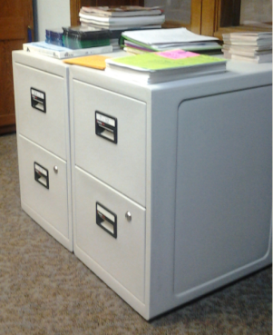

### Evidence 8.4 Immunization Audit.

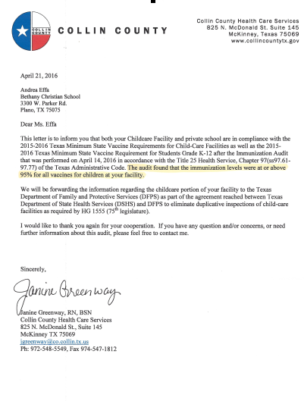

### Evidence 8.5 Records and School Closure.

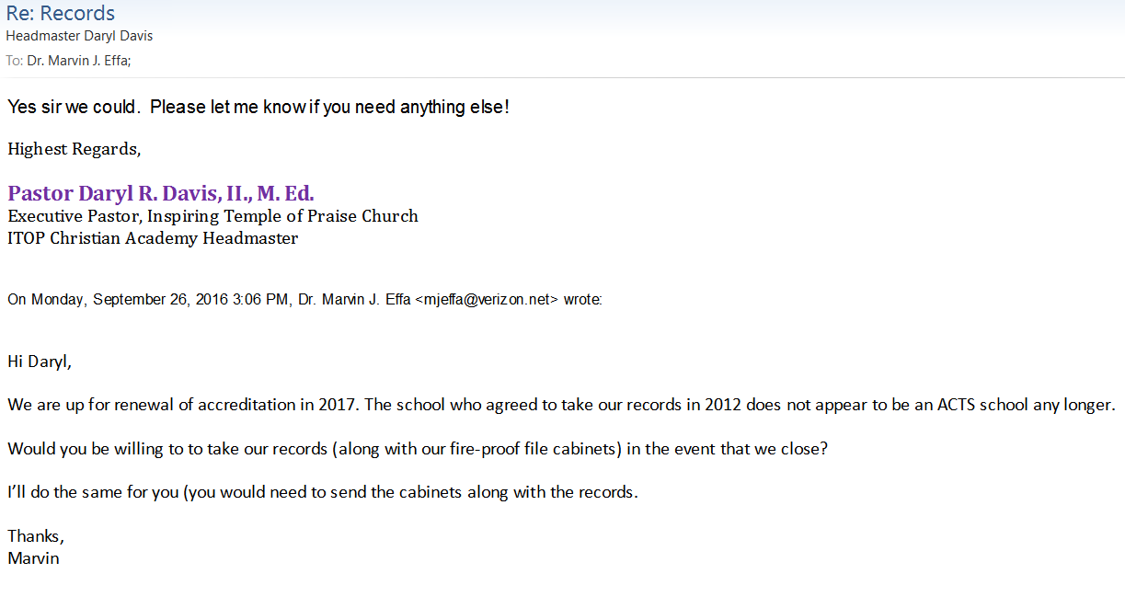

### Evidence 8.6a FERPA Policy.

The FERPA laws apply to schools that accept federal money. Since Bethany does not receive federal funds, the FERPA laws do not apply to us. We allow a parent supervised access to his/her student’s academic record regardless of the age of the student. Students over the age of 18 are allowed supervised access to his/her academic record.

[The Family Educational Rights and Privacy Act (FERPA) (20 U.S.C. § 1232g; 34 CFR Part 99) is a Federal law that protects the privacy of student education records. The law applies to all schools that receive funds under an applicable program of the U.S. Department of Education. http://www2.ed.gov/policy/gen/guid/fpco/ferpa/index.html]

### Evidence 8.6b Transfer of Records Policy.

Students enrolled at Bethany Christian School through the Federal government’s F-1 visa program (nonimmigrant students) are eligible to enroll in any other federally approved SEVP school. Bethany Christian will not transfer records of SEVP students to ineligible schools, nor will we assist them in the violation of the terms of the F-1 visa, nor will we provide benefits to them in the pursuit of actions in conflict with the terms of the visa.

### Evidence 8.7a Personnel File Index and 8.7b Personnel Records Policy.

|  |  |
| --- | --- |
|  |  |

# Standard 9, Student Activities

*All student activities:*

* 1. Shall be consistent with the school’s philosophy and objectives.

All school activities are consistent with the school’s philosophy and objectives and centered on Christian principles. We oversee the student activities to ensure that the discipleship goals for our students are enhanced and not interfered with by activities. For evidence that this standard is met, please view the annual yearbooks developed by our students and available for review in the front office. Yearbooks include the beginning of each school year until the deadline for publication in the late spring.

* 1. Shall be controlled by the school administration.

The administration must approve all school activities. The office and the teacher are responsible for all arrangements for each activity. Any field trip paperwork is handled through the school office so that, in the event of an emergency, copies of the necessary paperwork are with the staff members overseeing the activity.

* 1. Shall be staffed by personnel carefully selected on the basis of applicable background and training.

All activities have adequate salaried staff for the number of students. Volunteers may assist the staff. The staff/student ratio varies based on the age of the student and nature of the activity.

* 1. Shall be adequate in nature and type for the size of the school’s enrollment and grade level.

The school offers a variety of activities that are age-appropriate. Elementary grades participate in field trips, chapels and drama presentations, class parties, and Field Days. Secondary school students (grades 7-12) participate in chapel, academic competitions, weekly off-campus trips for PE, yearbook committee and an after-school sports program developed by the school’s Athletic Director. Our most elaborate program is a spiritual emphasis trip each spring, with over 20 successful experiences. These trips are Monday through Friday during the last week of February. We usually rent a camp that is responsible for the activities, with our staff responsible for the teaching/preaching. We now use the school’s bus for transportation. We also take selected students on leadership training campouts to Oklahoma. These Board-authorized outings are excused absences and involve a Thursday – Saturday trip. Activities include camping, tenting, lake activities, fire-making, and fire-arm safety classes at a nearby gun range. Last year the school spent $32,267 on activities for the students.

* 1. What percentage of your students participates in academic and co-curricular activities?

Virtually all of our 7th-12th graders participate in extra-curricular activities. There is a formal sports program that rotates through the seasons; these activities require official enrollment and practices in order to play competitively against other schools. Intramural sports are available for anyone who wishes; these are double elimination and are often played during lunch and immediately after school. Badminton and volleyball are typical examples of the non-formal sports. The school also provides for yearbook and computer code-writing clubs.

Commendations:

Recommendations:

# Standard 10, Publications

*All official school publications:*

* 1. Shall contain a statement of non-discrimination.

A clear statement of non-discrimination is included in all publications of the school. See Standard 7.4 for statement of school’s non-discrimination position. The school has also been approved by the Federal government to enroll nonimmigrant students. This privilege is available only after a rigorous examination by the Federal government; one of the government’s standards is non-discrimination.

* 1. Shall be true, accurate, and reflect ethical guidelines.

The most viewed public forum for the school is our website. We have structured the site to provide as much information about the school as is reasonable. The same documentation that our school families use is also available to the general public. We have found that it is best to be open, honest, and appropriate. We strive to follow ethical guidelines found in Scripture and to be “above reproach.”

* 1. The school shall have a student handbook that informs students and parents of the school’s philosophy, programs and support services such as academic calendar, attendance policies, guidance services, health services, transportation, food services, dress code, rules and regulations, discipline procedures, graduation requirements, grading scales and assessment policies.

The school student handbook is updated regularly, and its function is to state the policies by which the school is governed. In our community few parents request a written handbook, preferring to rely on the online version. The policy, stated in the handbook under “School Publications,” is that the online version is the most recent version and the one which all parties agree to follow. All of the items listed in Standard 10.3 are listed in the table of contents for the handbook. The academic calendar, which changes every year, is published on the website and is available in the school office. A copy of the current student handbook is in the school’s policy manual found in Section B; it is also listed separately under “Forms” on the website.

* 1. The school shall publish a faculty and personnel handbook which shall include the following: philosophy of the school, dress code, rules and regulations, discipline procedures, grading, and personnel evaluation policies, and a policy statement of due process and grievance procedures.

The school publishes a faculty and personnel handbook. It is available online and in print. All items listed in Standard 10.4 are listed in the table of contents for the handbook. A copy of the current faculty and personnel handbook is found in the school’s policy manual found in Section C. It is also found published separately on the church’s website.

Commendations:

Recommendations:

# Standard 11, Student Data Analysis

*The Leadership and Faculty:*

* 1. Shall see to the continuous collection, analysis and application of learning goals from a range of data sources, including comparison and trend data concerning student learning, instruction, program evaluation, and organizational conditions.

The school uses TerraNova testing during the first week of April. The information from these tests arrives after school is out; in June the administrators study the results and make notes for appropriate changes to the scheduling in the rising year. During in-service, instruction on data collection and analysis is provided by a senior administrator, with time given to implementing changes indicated by the standardized tests. Our curriculum relies heavily on demonstrated knowledge during exams and less on homework and quizzes. These exams become the basis for modifying the lesson plans to provide additional instruction as needed.

* 1. Shall facilitate annual training in best practices of evaluation, interpretation, and use of data.

Beginning in the summer of 2016, time has been scheduled with a senior administrator to instruct the staff on how to evaluate and interpret data. Proof of this training is found in the personnel files and is listed as a separate line-item of in-service training.

* 1. Engages in creating and implementing measurable and verifiable student learning goals based on multiple data points, which include but are not limited to standardized/norm referenced testing, formal and informal assessments.

The formal student learning goals are provided by the BJU Press curriculum. Each staff member has a teacher’s edition of the subject that specifies the purpose and learning goal of each lesson. The leadership and faculty interact with the students formally in the classroom and informally out of the classroom to measure and verify that the student has indeed internalized the concepts on a level deeper than simple recitation.

* 1. Shall monitor and communicate annually comprehensive information and analysis of student learning goals, conditions that support student learning, and the achievement of school improvement goals to stakeholders.

The school uses the collected data to increase student achievement in the future. The improvement plan is evaluated and changed in light of the information gathered.

Commendations:

Recommendations:

# Standard 12, Health, Safety, and Security

* 1. The school shall be safe, secure, clean, and meet all pertinent building, equipment, health requirements and legal requirements.

The school has security cameras, self-locking doors, and a closed-campus policy. The property and the play area is enclosed by a 6’ fence with locked gates. The only access is through the parking lot, and this is monitored by the security camera. During non-carpool hours, individuals must be buzzed into the building. Following the instructions of the Plano Police Department, certain individuals licensed by the State of Texas have been authorized to carry firearms on campus. These individuals have undergone additional training through the F.B.I.’s Citizens Academy for active shooter scenarios. A sign warning that authorized individuals are armed and will take appropriate measures to protect participants is located by the front doors.

The building is cleaned daily and maintenance is done on a regular basis.

All building permits are in order and the school is under the maximum occupancy allowed by the Special Use Permit.

Equipment not working properly is immediately removed from use and repaired or replaced.

Health requirements are met. The school has three Certified Food Managers and one Certified Food Handler. All staff members have been trained on Blood-Borne Pathogens and evidence of training is in the personnel files. Immunization records are current and are audited annually by the State of Texas. See Evidence 8.4. All staff has been trained in CPR, First Aide, and use of an AED which is located outside the school office. Proof of training is in the personnel files.

Texas no longer provides a summation of legal requirements for private schools. Texas is not included in the Department of Education’s list of the legal requirements for private schools. There is a PDF file located at *www2.ed.gov/admins/comm/choice/regprivschl/regprivschl.pdf* that provides a summation of legal requirements for Texas. Using this list as a guide, the school meets the legal requirements.

* 1. The school shall have policies that insure the security of students and staff (i.e. access to students, release of students and procedures relative to suspected child abuse).

As mentioned under Standard 12.1, safety and security of the people at the school is a priority. Access to the students is limited and background checks are required of all people who have access to the students during school hours. Individuals who attend public functions such as graduation and sporting events that are not held during school hours or are off campus are not required to undergo a background check. The policy for background checks for those not employed by the school is stated in the student handbook. Access to the school is provided through a buzzer system attached to a video feed. No one without a background check is allowed beyond the front office unless accompanied by a school staff member. Visitor and parents are required to wear a visitor’s badge; students leaving or arriving during the school day are admitted through the school office and the reasons are kept in a log.

Issues pertaining to child abuse are included in the Faculty and Personnel Handbook. Reporting procedures and general awareness are covered annually during in-service.

See Evidence 12.2 Criminal Background Check Policy.

* 1. The school shall have a Crisis Management Plan, to include as a minimum: Evacuation Plans; Lock-Down Procedures; Natural Disaster Responses; Grief Counseling (death of a student/staff); Media Communications Policy; Emergency Contact Numbers; and an Uninhabitable Building Plan (i.e., secondary location).

The Crisis Management Plan is located in the office and includes the minimum requirements. The Uninhabitable Building Plan is covered by the liability insurance. The school has adequate resources through insurance coverage to provide for 3 months of salaries and loss of income as well as coverage to provide funds to rent facilities. Once facilities are secured, the school is no longer without income. With funds available, a secondary location reasonably close the school may be secured. See Certificate of Liability Insurance (Standard 5) available on the website developed for the accreditation visit.

* 1. The school shall conduct fire and disaster drills in accordance with state and local regulations.

The State Fire Marshall’s Office recommends nine fire drills per school year and one tornado drill per year. Most years the school meets or exceeds the recommendations. The results are kept in a log in the school office in the front of the Crisis Management Plan Book. The fire and tornado alarms are two separate systems with distinct sounds. The fire alarm may be activated from all areas within the building; the tornado alarm can be activated only from the school office and the kitchen. The school intercom system is used to notify everyone that the siren is a drill and not an actual emergency. The school intercom is used to notify of other emergencies; we do not have a special notification system beyond fire and tornado. See Evidence 12.4a Fire/Tornado Log. See Evidence 12.4b Fire Tag Inspections.

* 1. The school shall provide adequate and consistent supervision of all students during all school activities (including drop-off and pick-up).

Teachers are present for drop-off in the morning. Pick-up in the afternoon involves three separate systems. Lower elementary goes out the back doors at the south-east corner of the building. The covered walkway that goes to the parking lot is where they are placed into the cars by the staff. Middle range students 5-8th grades are taken out the front doors and placed in the cars. High school students are allowed to activate their cell phones at 3:30. Their drivers must be in a parking space in the front parking lot. The students exit the back west doors during good weather and cross the fire lane where a teacher assists them across the lane. In recent years we have seen a significant increase in non-professional “taxi” services, such as Uber and Lyft. These services regularly ignore the traffic patterns and signs, and typically come to our campus only once. During bad weather the students exit the front doors and cross the fire lane by the front door with the oversight of a teacher.

* 1. The school shall have, if transportation services are provided, procedures and regulations designed to safeguard students.

The school owns a transit bus that is fully insured and inspected annually by a certified for busses, DOT-approved truck and bus repair business located north of McKinney (the nearest DOT certified repair shop). We have two drivers with advanced training and commercial CDL licenses that have the required specific school-bus endorsement. We also have a hired non-owned rider on our insurance policy in the event that we utilize our parents as drivers. See Evidence 12.6a Insurance Card for Bus; 12.6b Hired Non-owned Coverage.

Commendations:

Recommendations:

### Evidence 12.2 Criminal Background Check Policy.

**From Student Handbook:**

**Criminal Background Checks**

Everyone must undergo a background check before having access to the students. When arriving on campus, please go directly to the office and fill out the background check paperwork. The cost for the background check is $15, payable at the time of the visit. Volunteers wishing to transport students will also have a driving license check at the same time as the background check. The administration will notify the applicant of any problems that arise from the background check. After consultation with the applicant, appropriate action will be taken. All background check applications are kept in locked, fireproof file cabinet. Attendees at public events such as the Christmas program and graduation do not require a background check. Everyone attending events held during school hours (7 a.m. – 6 p.m.) must have a background check on file.

Schools that receive federal funding are required to FBI fingerprint everyone who has regular access to students. Since Bethany does not receive federal funds, we do not normally require FBI fingerprinting.

[<http://www.tea.state.tx.us/index2.aspx?id=5613> “In 2007, the Texas Legislature passed a law requiring fingerprint-based criminal background reviews for certain school employees. The legislation was enacted to ensure the safety of all children, teachers and staff in Texas public schools.”]

### Evidence 12.4a Fire/Tornado Log.

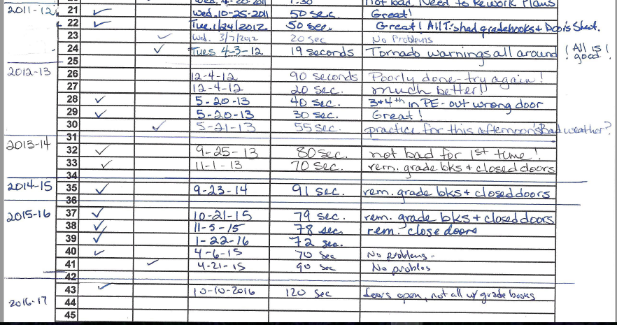

### Evidence 12.4b Fire Tag Inspections.

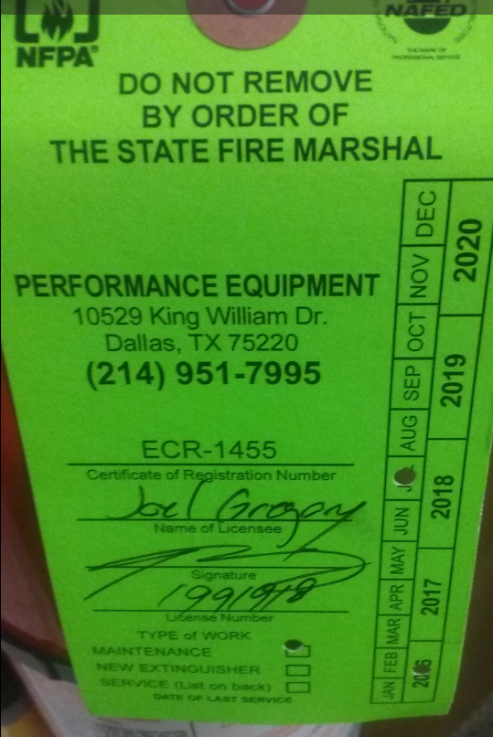 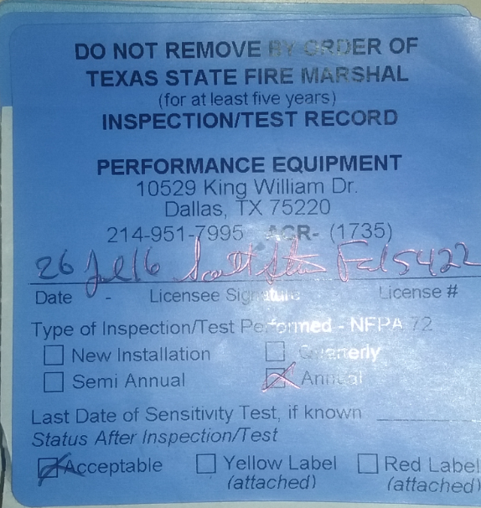

### Evidence 12.6a Insurance Card for Bus.

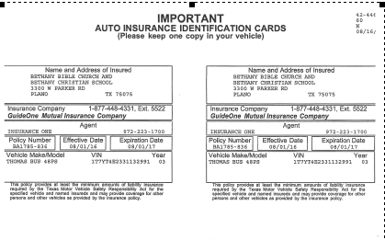

### Evidence 12.6b Hired, Non-owned Coverage.

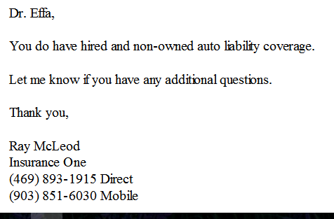

# APPENDIX 1 ACTS Statement of Faith

**ASSOCIATION OF CHRISTIAN TEACHER AND SCHOOLS**

**STATEMENT OF FAITH**

* We believe the Bible to be the inspired, the only infallible, authoritative Word of God.
* We believe that there is one God, eternally existent in three persons: Father, Son and Holy Spirit.
* We believe in the deity of our Lord Jesus Christ, in His virgin birth, in His sinless life, in His miracles, in His vicarious and atoning death through His shed blood, in His bodily resurrection, in His ascension to the right hand of the Father, and in His personal return in power and glory.
* We believe that for the salvation of lost and sinful people, regeneration by the Holy Spirit is absolutely essential.
* We believe in the present ministry of the Holy Spirit by whose indwelling the Christian is enabled to live a godly life.
* We believe in the resurrection of both the saved and the lost; they that are saved unto the resurrection of life and they that are lost unto the resurrection of damnation.
* We believe in the spiritual unity of believers in our Lord Jesus Christ.